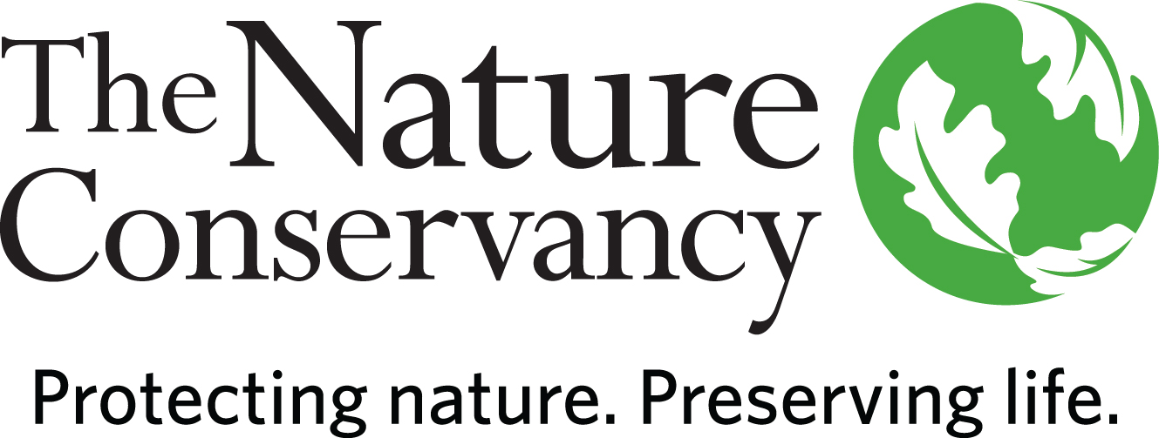
Permit #___________

Permit ID: __________

Project ID: _________

INSTRUCTIONS: This Research Permit Application, including the signed Research Permit and Agreement, Exhibit A- Research Permit Application, and Exhibit B- Research Liability Waiver, must be emailed to elizabeth.bach@tnc.org for TNC review. Application review may take up to 30 days. The Research Permit and Agreement is not effective until the Research Permit Application is approved and signed by both TNC and Researcher.

Research Permit and Agreement
(August 2023 revision)

This Research Permit and Agreement (this “Permit”) is granted by The Nature Conservancy, a District of Columbia non-profit corporation (“TNC”) to the Research Permit holder identified as “Researcher” on Exhibit A attached and made a part of this Permit (the “Research Permit Application”) and is effective as of the date TNC executes the Research Permit Application indicating its approval of the Research Permit Application.

The Nachusa Grassland Preserve located in Lee and Ogle Counties, Illinois, (the “Preserve”) is owned and managed by TNC. TNC issues Research Permits for the Preserve to allow controlled access for scientific research.

In consideration of TNC granting this Permit to Researcher to conduct research activities described in the Research Permit Application (the “Activities”) on the Preserve, Researcher agrees, represents, and warrants as follows:
- Researcher will sign and submit to TNC the Research Liability Waiver in the form attached to this Permit as Exhibit B (the “Waiver”) and will ensure all persons entering the Preserve who are participating in, assisting with, and/or accompanying Researcher (collectively “Research Assistants”) also sign and submit the Waiver before they enter the Preserve. The Researcher is responsible for any and all actions of any and all Research Assistants while on the Preserve.
- Researcher will abide by and will cause all Research Assistants to abide by all rules and regulations identified in this Permit while conducting the Activities on the Preserve and will comply with and cause all Research Assistants to comply with all additional instructions or directions, either oral or written, from TNC.
- Researcher and Research Assistants (collectively, “Research Team”) must keep this Permit with them while on the Preserve and conduct the research in accordance with this Permit. Modifications to an approved research project require advance written authorization from TNC.
- This Permit automatically terminates on 31 December 2024 unless terminated earlier by TNC. TNC reserves the right to terminate this Permit at any time.
- By 30 January 2025, Researcher must submit an annual report to elizabeth.bach@tnc.org via email. This obligation will survive the earlier termination of this Permit. Failure to submit an annual report may result in denial of future research permit requests. Reports must include:
  - name of the Preserve and date(s) visited;
  - numbers of specimens and species collected, fate of specimens after collection, and date;
  - a brief summary of project and results;
  - copies of all publications derived from research conducted under the Permit;
  - a list of all presentations/posters derived from research conducted under the Permit; and
  - a description of the data sets, including stored location and a list of data fields recorded (e.g., plant mass, animal species, soil carbon concentration).
- Research Team will acknowledge and give proper credit to TNC in all published papers and presentations relating to research or studies conducted on the Preserve pursuant to this Permit. The acknowledgement will be in a form approved by TNC. This obligation will survive the termination of this Permit.
- Researcher’s contact information, a general description of the Activities, and the annual reports described in this Permit may be shared by TNC with other Research Team and interested parties.
- Research Team will not engage in any Activities on the Preserve that are unlawful, improper, or contrary to any applicable law, regulation, or ordinance.
- Researcher Team will conduct themselves at all times in a manner that respects the Preserve’s integrity and will take care to safeguard the condition of the Preserve and the natural resources thereon.
- Research Team will not collect, remove, disturb, harm, harass, take, or destroy any rocks, minerals, plants, artifacts, animals, specimens, or matter, nor parts thereof, except to the extent specifically authorized in writing by this Permit. Except as authorized by this Permit, all Activities must be non-invasive. Even where collection or other invasive Activities are authorized, Research Team will always minimize disturbance and will not cause long-term impacts to natural communities or populations. Research Team will use reasonable efforts to minimize negative impacts associated with conducting research on the Preserve and will access the preserve in a manner that causes the least disturbance to flora/fauna and infrastructure while also minimizing distances traveled. Research Team will follow proper use of vehicles and equipment. If TNC staff identifies negative impacts or wasteful practices that could affect the Preserve, Research Team must cooperate with TNC staff to limit the impacts.
- Research Team will not make or permit any use of the Preserve, including collecting, which is unlawful, improper, or contrary to any applicable federal or state law or local ordinance, and will obtain, at its sole cost and expense, any and all permits or authorizations required by law to conduct the Activities on the Preserve. Researcher agrees to bear all responsibility for and indemnifies TNC for all fines and penalties imposed for violations of any laws or regulations or any permit/authorization terms, and to hold TNC harmless therefor. Researcher must submit copies of all permits and authorizations to TNC before any work is done on the Preserve.
- Research Team will:
- obtain a permit from the Illinois Department of Natural Resources if proposed research involves a state-listed threatened or endangered species;
- assume rarity when encountering any unfamiliar plant or animal and to seek specific guidance from TNC to determine if a particular species or community is rare or imperiled;
- take appropriate protective measures to ensure flora/fauna known or suspected to be rare or imperiled will not be disturbed;
- collect conservatively and be constrained to the kinds and numbers of specimens specifically authorized by this Permit; and
- collect in a discreet manner, away from roads, trails, and developed areas unless specified otherwise, and are required to minimize damage.
- All property (equipment, vehicles, etc.) brought onto the Preserve by Research Team will be stored and used in a manner that does not interfere with the continued use of the Preserve by TNC and other visitors and that does not cause a nuisance or danger to others nor create an unsightly condition. While on the Preserve, Research Team will conduct themselves so as not to threaten the health or safety of others and will refrain from interfering with the quiet enjoyment of any other persons who may be on or near the Preserve.
- The following are prohibited on the Preserve without written authorization from TNC:
- camping,
- fires,
- possession of a weapon,
- alcoholic beverages, and
- pets (service animals are permitted).
- No substances, chemicals, materials, or wastes, may be brought, utilized, stored, processed, transported, disposed of, dumped, or released on, under, about, or from the Preserve without written authorization from TNC.
- Research Team will not install or erect any permanent or temporary structures, fixtures or attachments on the Preserve without written authorization from TNC.
- TNC reserves the right to remove or relocate Research Team’s equipment located on the Preserve.
- Research Team must be aware of TNC’s property boundaries and avoid trespassing on property adjacent to the Preserve.
- Research Team must obtain authorization from landowner(s) for access to lands or waters owned by a person or entity other than TNC.
- Access to the Preserve must be along existing roads. Research Team will not use off-road vehicles without written authorization from TNC.
- TNC reserves the right to restrict access to any area of the Preserve at any time for any reason. In such event, Research Team will not use such area(s) in any manner whatsoever. TNC also reserves the right to use and to permit others to use areas of the Preserve that are being accessed by Research Team. However, TNC will make reasonable efforts to avoid interfering with research projects.
- Research Team must avoid hunting areas on posted days and times of hunting. Signs are posted at all entrances to affected units during these times.
- Research Team will exercise the highest degree of care in the conduct of the activities permitted pursuant to this Permit, to avoid the risk of personal injury or property damage. Researcher hereby assumes all responsibility for any injury to persons, including but not limited to Research Assistants, or damages to property which occur in connection with Researcher’s use of the Preserve pursuant to this Permit. Researcher, for itself, its successors and assigns, hereby agrees to release, indemnify, defend and hold TNC harmless from any and all claims, liabilities, losses, damages, costs, and expenses incurred in connection with the presence of Research Team on or over the Preserve or in connection with Researcher Team’s activities on or over the Preserve, including but not limited to any damage or loss to Researcher’s property incurred by virtue of its operation and/or presence on the Preserve. THIS RELEASE AND INDEMNITY INCLUDES, WITHOUT LIMITATION, ANY LIABILITY, DAMAGES, CLAIMS, LOSS, EXPENSES AND JUDGMENTS ARISING OUT OF OR ALLEGED TO ARISE OUT OF, IN WHOLE OR IN PART, BY THE NEGLIGENCE OF GROSS NEGLIGENCE (OR ANY OTHER THEORY OR RECOVERY) OF TNC. Researcher’s release, indemnity and defense obligations under this Permit will survive expiration or earlier termination of this Permit.
- The exhibits attached hereto are incorporated into this Permit by reference and made a part hereof as if fully set forth herein.

Permit #_________ Permit ID: ________ Project ID: _______

Exhibit A

RESEARCH PERMIT APPLICATION

READ ALL THE INFORMATION BELOW PRIOR TO SUBMISSION OF YOUR APPLICATION. FILL IN ALL FIELDS OR INDICATE NOT APPLICABLE (NA) WHERE APPROPRIATE.

- Researcher’s Full Name: Major Professor (if applicable):

- Affiliation: Position:

- Address: E-mail address:

- Office Phone: Cell Phone:

- General field of interest and professional qualifications:

- List all pertinent permits held:

- Is this a renewal? If yes, you still must fill out this entire form. Please CAPITALIZE text
that reflects any change(s) from last year.

- Is this associated with a TNC contract?

- Short project title (5-word limit):

- Name of Preserve: Nachusa Grasslands

- Time, frequency, and length of anticipated visits and number in party:

- List name(s) and role(s) of other assistants/participants:

- Duration of project (with dates):

- General description of research including objective(s):

- Location of research site(s). Please provide GPS coordinates or draw on maps below:

- List species and/or materials to be collected:

- Method of collection(s):

- Number of specimens and deposition:

- Other disturbances to be made:

- List records to be kept:

- Describe the kinds and amounts of any hazardous chemicals you need to bring onto the Preserve and disposal methods:

- Mode used to access the site (e.g., walking, truck, UTV, etc.)

- OTHER PERTINENT INFORMATION:
25. Special instructions if applicable (TNC completes).

26. TNC Project(s) names (TNC completes).

I am acknowledging that by typing my name below, I have (i) reviewed and agree to the Consent to Use Electronic Records and Signatures, and (ii) electronically signed this Research Permit Application and the Research Permit Agreement to which this Research Permit Application is attached and integrated by reference and agree to their terms. Consent to use electronic records/signatures

RESEARCHER:
[Institution or Entity Name if Applicable]

By: ___________________________________________
Print Name: ____________________________________
Title (if applicable): _______________________________
Date: __/__/____

TNC:
The Nature Conservancy, a District of Columbia non-profit corporation

By: ___________________________________________
Print Name: ____________________________________
Title (if applicable): _______________________________
Date: __/__/____

Exhibit B
Research Liability Waiver

This RESEARCH LIABILITY WAIVER (this “Waiver) is valid only in association with Research Permit # ______________ (the “Permit”) held by _________________________________ (print name/affiliation of permitted researcher) (“Researcher”) granted by The Nature Conservancy, a District of Columbia non-profit corporation (“TNC”) for research at Nachusa Grasslands Preserve.
Research to be conducted at the Nachusa Grasslands Preserve in Lee and Ogle Counties requires a Research Permit from TNC.
Anyone entering the Preserve to conduct the activities described in the Permit (the “Activities”) under authority of the Permit must first completely fill out and file with TNC this Waiver before entering the Preserve to perform the Activities. Properly completed and signed waivers must be submitted to Elizabeth Bach, The Nature Conservancy, elizabeth.bach@tnc.org. In consideration of the permissions granted in the Permit I agree as follows:

- I have read and understand, am subject to, and will abide by all rules and regulations identified on the Permit while performing or assisting with research on the Preserve and will comply with all instructions or directions, either oral or written, from TNC.

- I will conduct all Activities on the Preserve in accordance with the Permit. I agree and acknowledge that TNC makes no express or implied warranty or representation whatsoever about the Preserve, including without limitation, about i) the safety, condition, or suitability of the Preserve, lodging, or other premises, structures, or improvements thereon for any purpose whatsoever, or ii) the accuracy or completeness of any map or survey of the Preserve.

- I understand the possible dangers that might be involved in the type of Activities I will be participating in. I am aware of no problem or condition that could endanger others or myself if I and/or my Research Team (as that term is defined in the Permit)/assistants/ participants participate in Activities at the Preserve. All of my activities at the Preserve are at my own Risk.

- I for myself and my heirs, hereby waive, release, indemnify, and hold harmless TNC and its officers, directors, and employees from any and all claims, liabilities, losses, damages, and expenses incurred in connection with my presence and Activities on the Preserve and the foregoing actions and circumstances resulting from any injury to me or damage to my property at the Preserve.

- I grant TNC permission to take photographs, video, and audio representations of me while at the Preserve. I hereby irrevocably consent to and authorize the royalty free use and reproduction by TNC, or anyone duly authorized by TNC, of any and all such photographs (including negatives) and video/audio representations for any legitimate purposes, including but not limited to advertising, trade and editorial purposes, at any time in the future in all media now known or hereafter developed, throughout the world. I also consent to the use of my name in connection with such photographs, video and audio representations and writings under the same terms. I hereby release, indemnify and hold harmless TNC and its officers, directors, agents, and employees from any and all claims which may result at any time by reason of the use of my image, video and audio representations, writings and name, including, without limitation, claims of privacy. My heirs, executors, administrators, and assigns will be bound by this consent and release.

BY SIGNING, I ACKNOWLEDGE I AM AT LEAST 18 YEARS OF AGE, OR IF NOT, THE SIGNATURE OF A PARENT OR GUARDIAN IS PROVIDED BELOW. I UNDERSTAND THE USE OF THIS PRESERVE IS A PRIVILEGE GRANTED TO ME AND THIS PRIVILEGE MAY BE REVOKED AT ANY TIME. I CERTIFY I HAVE READ AND UNDERSTAND THE PERMIT REQUIREMENTS, CONDITIONS AND RULES ABOVE, AND I WILL ADHERE TO THEM, AND THAT THE INFORMATION PROVIDED IN THIS DOCUMENT IS TRUE AND ACCURATE TO THE BEST OF MY KNOWLEDGE.

I am also acknowledging that by typing my name on this Research Liability Waiver, I have (i) reviewed and agree to the Consent to Use Electronic Records and Signatures, and (ii) electronically signed this Waiver and agree to its terms. Consent to use electronic records/signatures

NAME:

TELEPHONE: EMAIL:

SIGNATURE: DATE:

PARENT OR GUARDIAN SIGNATURE FOR LISTED MINOR: DATE:

Map of Nachusa Grasslands – North units
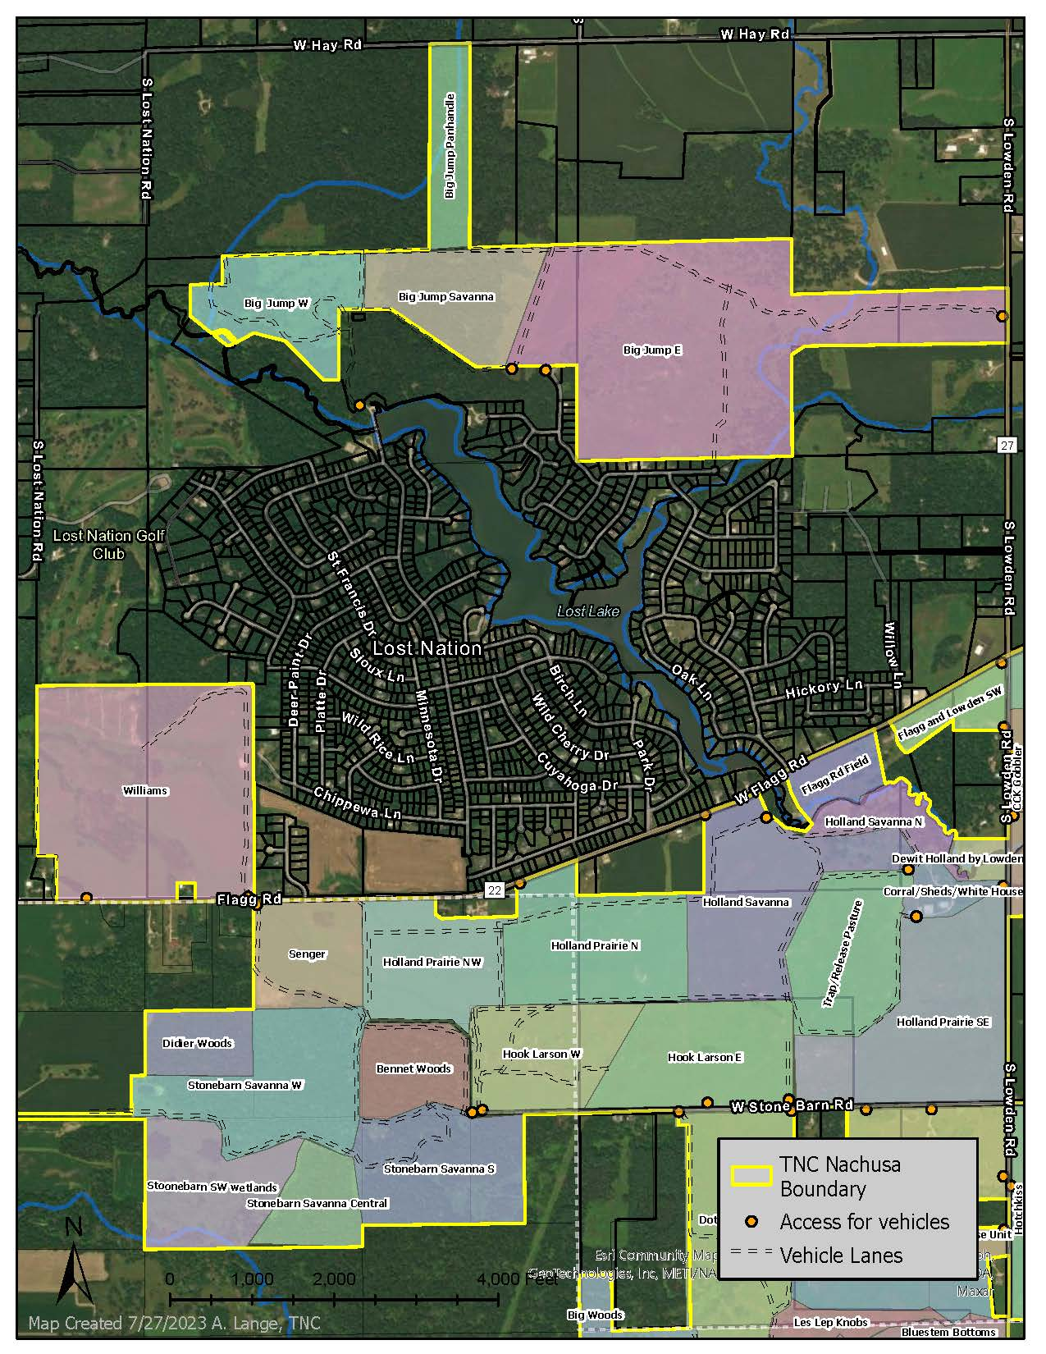

Map of Nachusa Grasslands – South units
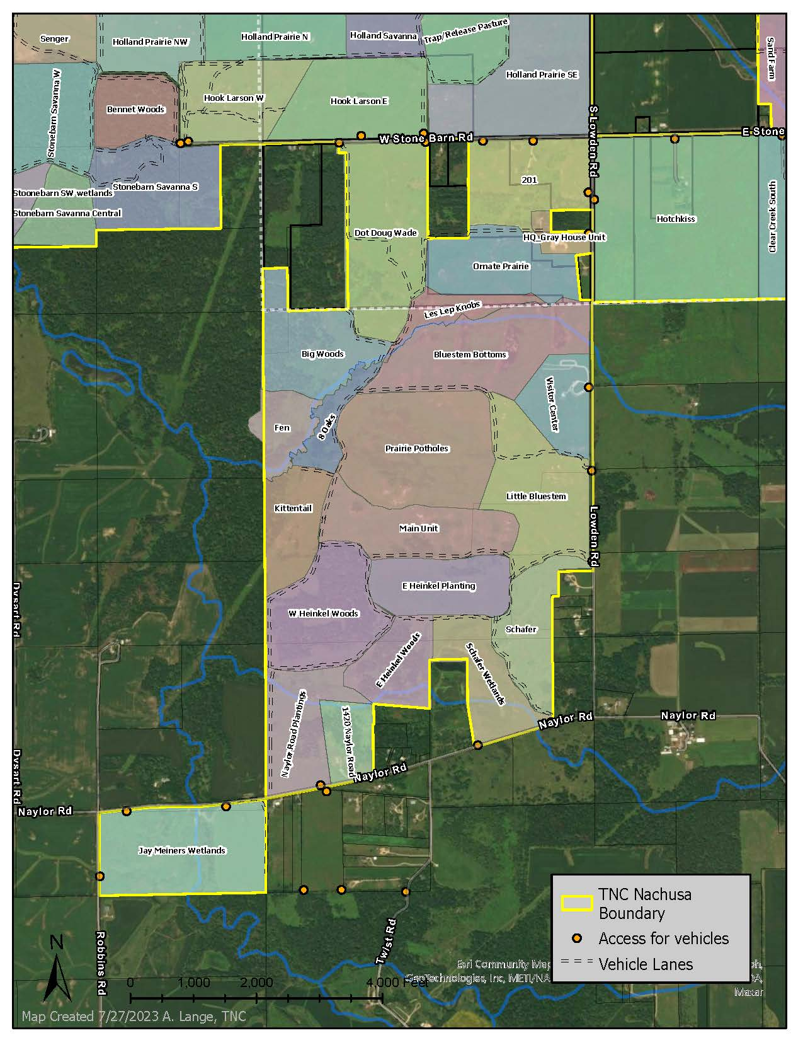

Map of Nachusa Grasslands – East units
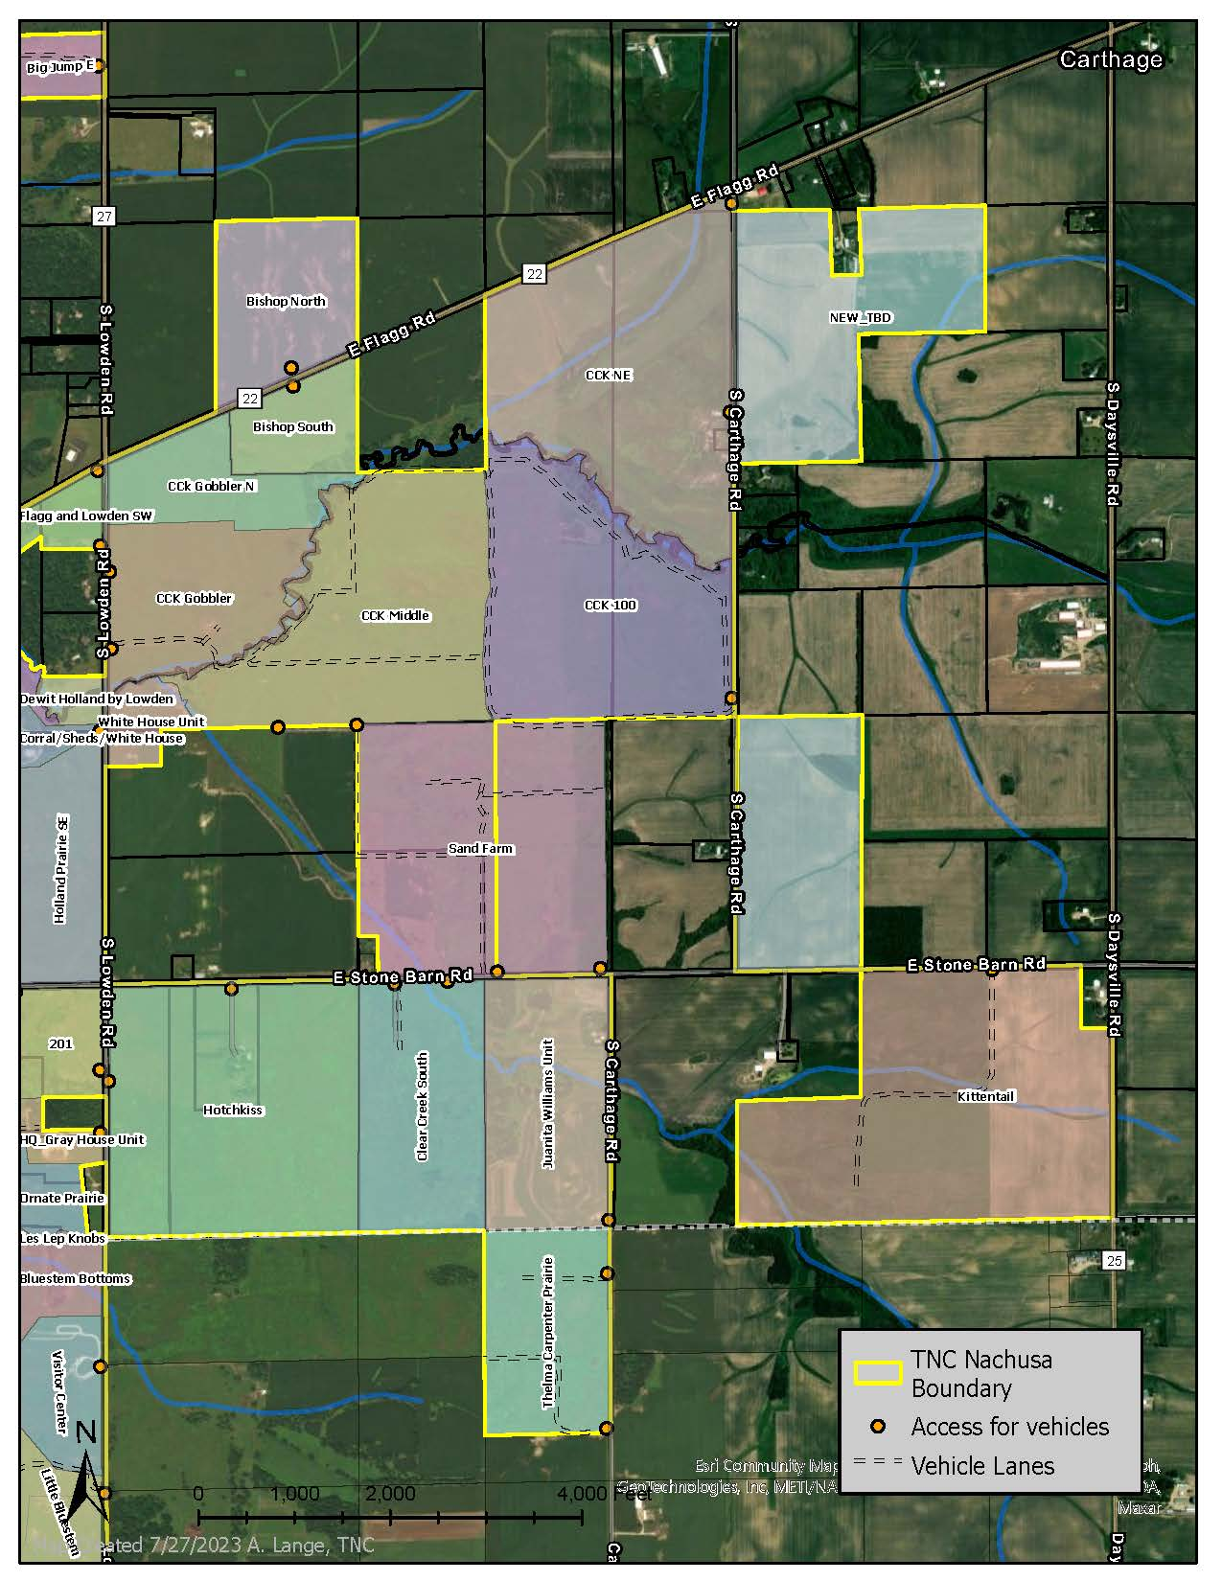
Stone Barn Farm

